# **Upticknetwork Blog Banner | Guide**

### **About the banners**

To keep consistency across publications, Upticknetwork branded banners always follow the same layout.

Banner guidelines

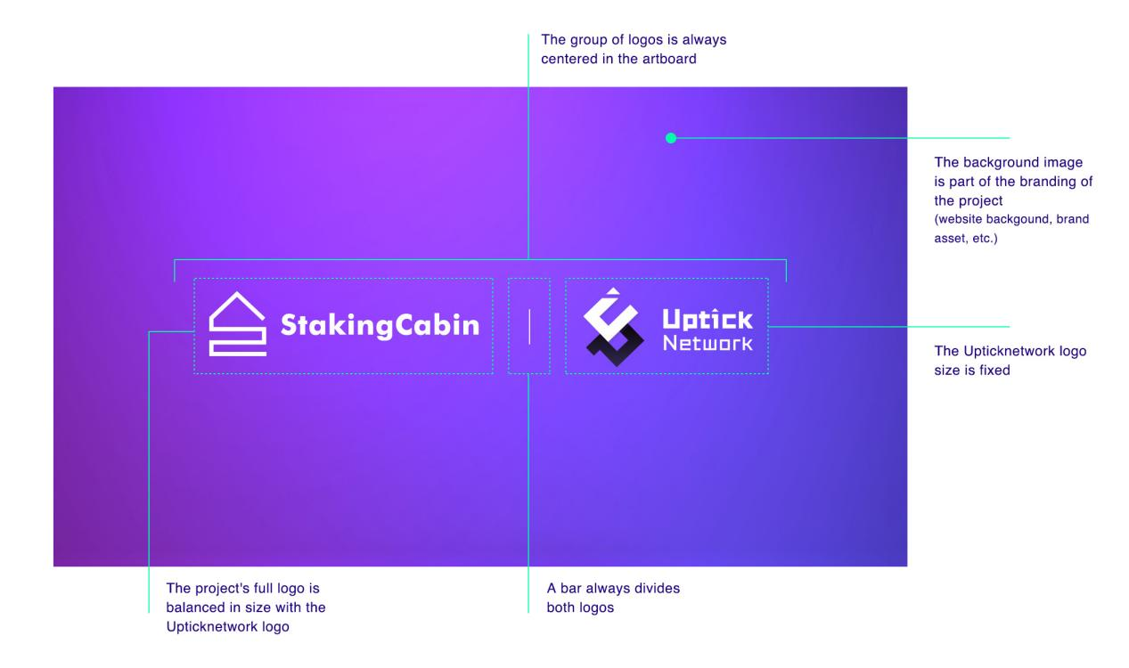

### **Creating your own banner**

In order to create your own banner, we put together a series of templates that you can download or use.

Adobe Illustrator file

If you or your team uses Adobe Illustrator, this template will help you create the banner. The template includes all the elements divided in layers and a guide on the colors for the Upticknetwork logo in case you need to adjust the contrast based on your background.

**[Download](https://drive.google.com/file/d/1IRyr-HhYkgzImJL71yGyzA-prIBvzj4p/view?usp=sharing)**

Logo for light background

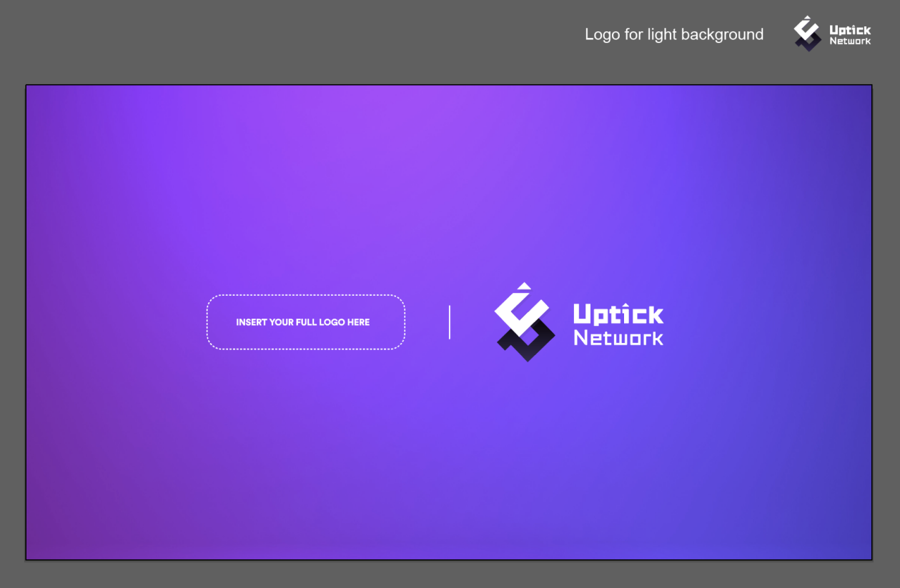

Logo for dark background

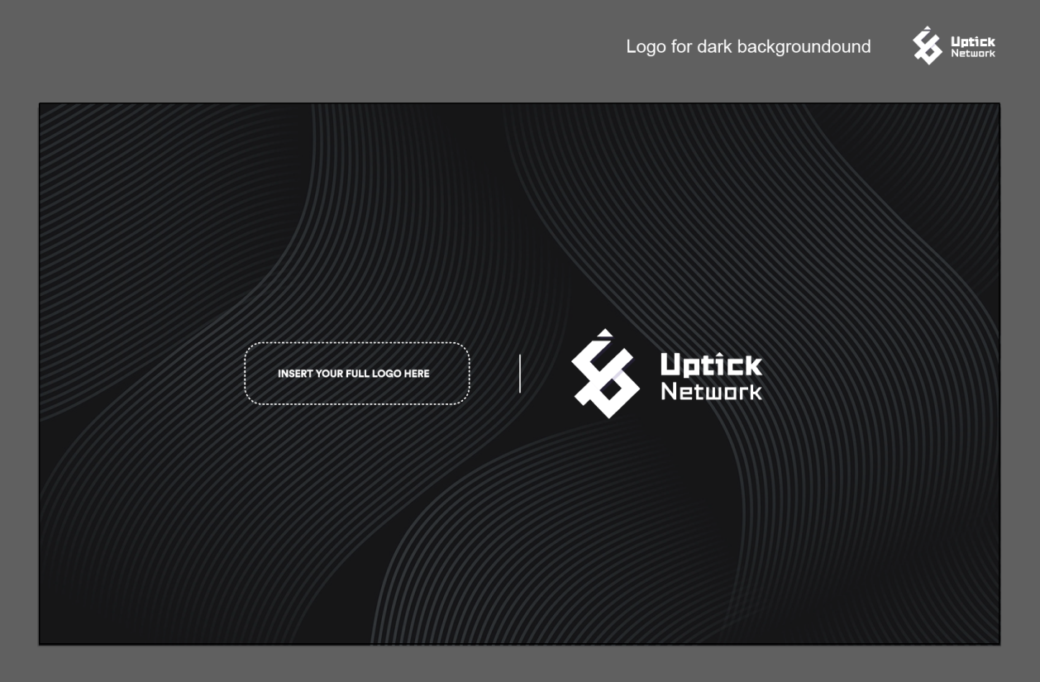

Logo for white background

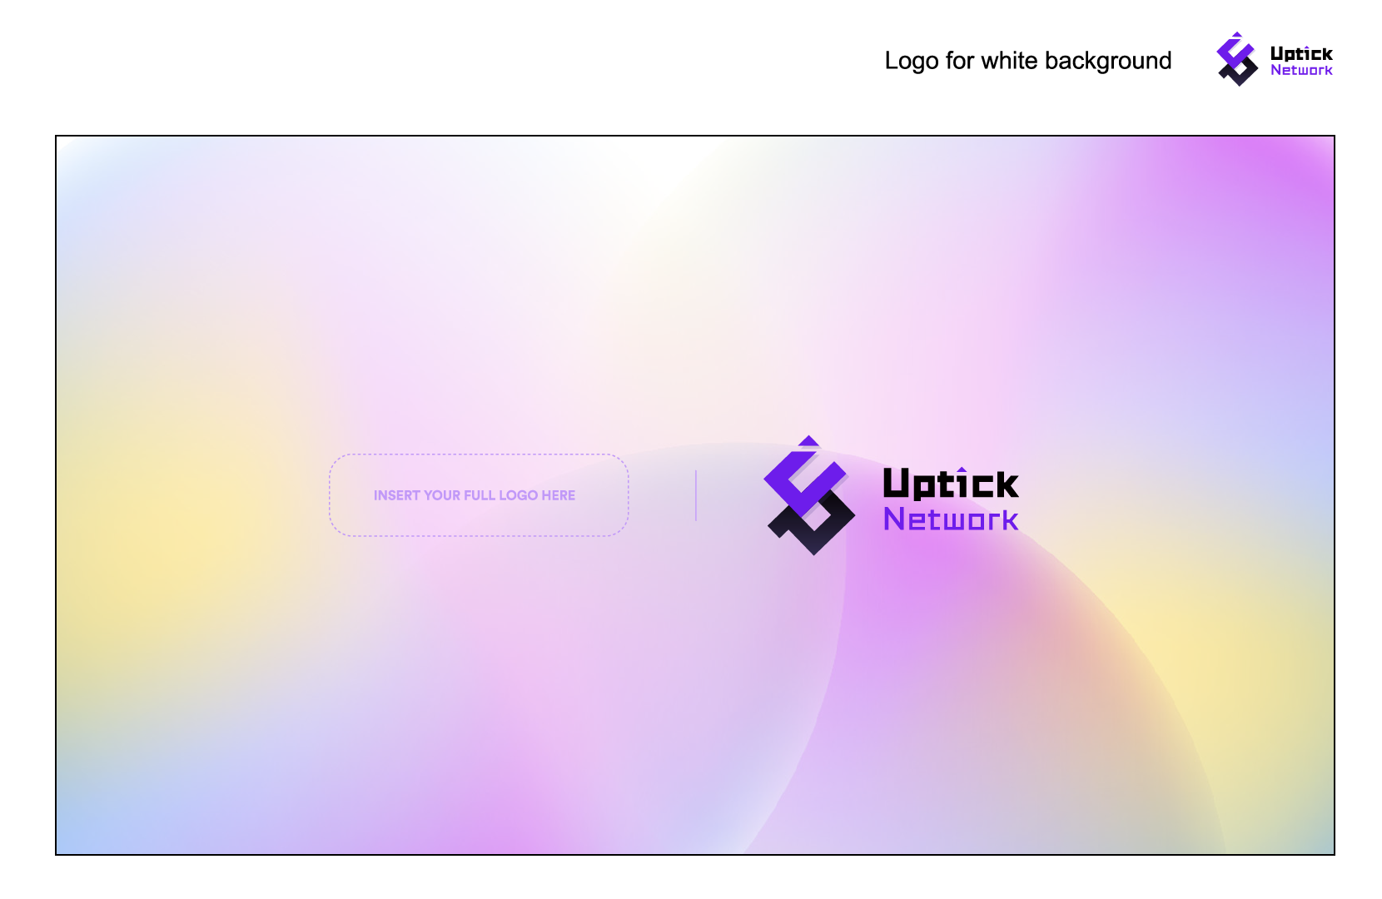

### **Brand assets and examples**

Additional Upticknetwork logos that can be used to create a banner can be found at xxxxxxxxxxxxxx. We also included two banner examples below:

